|  |  |
| --- | --- |
| Roll. No. A016 | Name: Varun Mahendra Khadayate |
| Class B.Tech CsBs | Batch: 1 |
| Date of Experiment: 18-12-2021 | Date of Submission:18-12-2021 |

# Aim

Case Study on Cisco Packet Tracer

# Cisco Packet Tracer

Packet Tracer is a cross-platform visual simulation tool designed by Cisco Systems that allows users to create network topologies and imitate modern computer networks. The software allows users to simulate the configuration of Cisco routers and switches using a simulated command line interface.

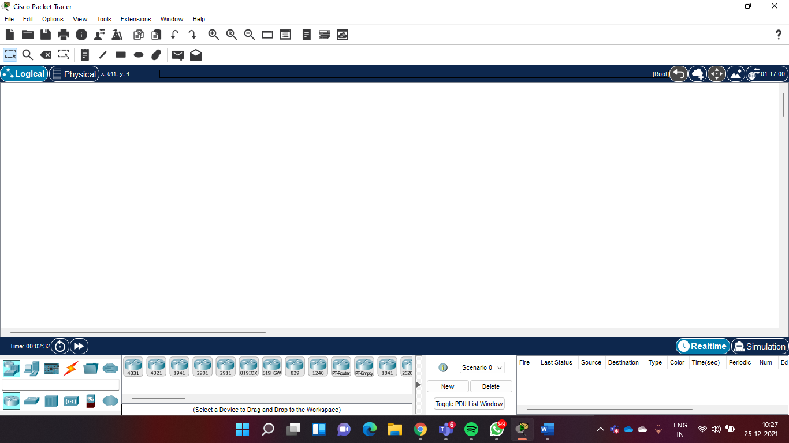

## Menu bar –

This is a common menu found in all software applications; it is used to open, save, print, change preferences, and so on.



## Main toolbar –

This bar provides shortcut icons to menu options that are commonly accessed, such as open, save, zoom, undo, and redo, and on the right-hand side is an icon for entering network information for the current network.



## Logical/Physical workspace tabs –

These tabs allow you to toggle between the Logical and Physical work areas.



## Workspace –

This is the area where topologies are created and simulations are displayed.

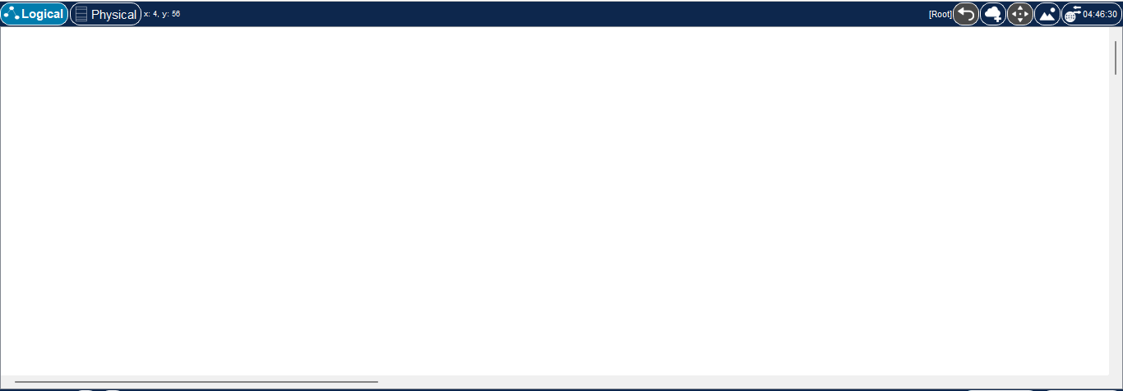

## Common tools bar –

This toolbar provides controls for manipulating topologies, such as select, move layout, place note, delete, inspect, resize shape, and add simple/complex PDU.



## Realtime/Simulation tabs –

These tabs are used to toggle between the real and simulation modes. Buttons are also provided to control the time, and to capture the packets.



## Network component box –

This component contains all of the network and end devices available with Packet Tracer,

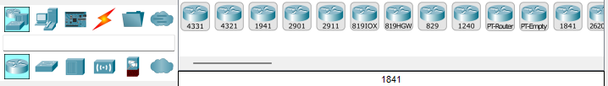

and is further divided into two areas:

### Device-type selection box –

This area contains device categories



### Device-specific selection box –

When a device category is selected, this selection box displays the different device models within that category



## User-created packet box –

Users can create highly-customized packets to test their topology from this area, and the results are displayed as a list.

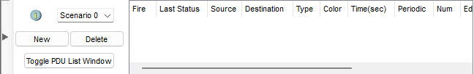

## Network Devices

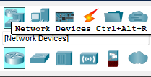

### Routers

A router provides connectivity between two logical networks. Every router in Packet Tracer can be switched on or off by using the provided power button. The power switch is required to make a device simulate its real counterpart. Modules can be added or removed only after powering off the device. If the running configuration is not saved, power cycling a device will make it lose its configuration.

The following routers are available in Packet Tracer:

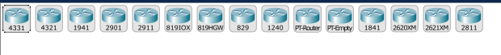

#### Cisco 1841:

This is an Integrated Service Router (ISR) having two Fast Ethernet ports, two slots for High-Speed WAN Interface Cards (HWICs), and one slot for Advanced Integration Module (AIM)

#### Cisco 1941:

This is similar to the previous model but runs on Cisco IOS Version 15. It has two ports that operate at Gigabit Ethernet speeds.

#### Cisco 2620XM:

This is a multiservice router with one Fast Ethernet port, two slots for WAN Interface cards, and one slot for AIM.

#### Cisco 2621XM:

This is similar to the previous model, except that this router has two Fast Ethernet ports.

#### Cisco 2811:

This ISR comes with two Fast Ethernet ports, four WIC slots, and a dual slot for AIM.

#### Cisco 2901:

This router has two Gigabit Ethernet ports, four WIC slots, and two Digital Signal Processor (DSP) slots. This router uses Cisco IOS Version 15.

#### Cisco 2911:

This router has three Gigabit Ethernet ports and all the other features of the previous router. It runs on IOS Version 15. • Generic Router-PT: This is a custom router running on Cisco IOS. It contains 10 slots and has separate modules with a naming convention beginning with PT.

### Switches

A switch, also called a multiport bridge, connects more than two end devices together. Each switch port is a collision domain. The following switches are available in Packet Tracer:



#### Cisco 2950-24:

This managed switch comes with 24 Fast Ethernet ports.

#### Cisco 2950T-24:

This switch is a member of the Catalyst 2590 Intelligent Switch family and has two Gigabit Ethernet ports in addition to the 24 Fast Ethernet ports.

#### Cisco 2960-24TT:

This is another 24 port switch; the previous switch has Gigabit Interface Converter (GBIC) for Gigabit Ethernet ports, whereas this switch has Small Form-factor Pluggable (SFP) modules for the same. Note that this is a difference only on real switches, it has no impact on Packet Tracer.

#### Cisco 3560-24PS:

This switch is different from the others because it is a layer 3 switch that can be used to perform routing in addition to switching. The PS suffix implies support for Power over Ethernet (PoE), which can be used to power up IP phones without using power adapters.

#### Bridge PT:

This is a device used to segment a network and it has only two ports (which is why it is a bridge; if it had more, it'd be called a switch).

#### Generic Switch PT:

This is a Packet-Tracer-designed switch running on Cisco IOS. This is the only customizable switch with 10 slots and several modules.

### Hubs

#### Hub PT:

This network hub was the oldest way to connect multiple end devices together. It still exists in Packet Tracer so that you can simulate and learn about network storms and broadcasts. This Packet Tracer device has 10 slots.

#### Repeater PT:

This device is used to boost the signal on a wire when the distance between two points is high. this device has two slots.

#### Coaxial Splitter PT:

This is used to split a single coaxial connector into two. It has three coaxial ports and cannot be customized in any way.

## Customizing devices with modules

A device module is a piece of hardware containing several device interfaces. For example, a **Cisco 2901** this router has two Gigabit Ethernet ports, four WIC slots, and two Digital Signal Processor (DSP) slots. This router uses Cisco IOS Version 15.

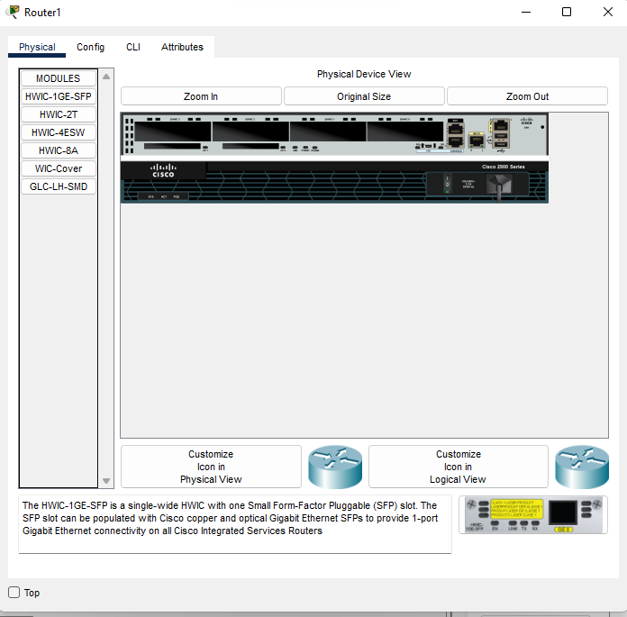

The power switch is on the right-hand side of each device, with a green LED indicating that the power is on. Click on this switch to turn it off. To add a module, drag one from the modules list and drop it onto an empty slot. If a module doesn't fit into that slot, it automatically returns to the module list.

Each router has more than a dozen modules but the interface they offer can be identified by their names.

### HWIC-1GE-SFP

Is a single-wide HWIC with one Small Form-Factor Pluggable (SFP) slot. The SFP slot can be populated with Cisco copper and optical Gigabit Ethernet SFPs to provide 1-port Gigabit Ethernet connectivity on all Cisco Integrated Services Routers

### HWIC-2T

Is a Cisco 2-Port Serial High-Speed WAN Interface Card, providing 2 serial ports.

### HWIC-4ESW

Provides four switching ports.

### HWIC-8A

Provides up to eight asynchronous EIA-232 connections to console ports.

### WIC-cover plate

Provides protection for the internal electronic components. It also helps maintain adequate cooling by normalizing airflow.

1000BASE-LX/LH SFP

Operates in Gigabit Ethernet ports of Cisco Industrial Ethernet and SmartGrid switches and routers

## Connections

Choosing the Connections icon from the device-type selection box lists several cables in the device-specific selection box. Packet Tracer provides the following cables that can be used to connect devices:

#### • Console:

This is a console cable that is used to view the network device's console from a PC/laptop. One end of the cable connects to the console port of a network device while the other one connects to the RS-232 port on a PC/laptop.

#### • Copper straight-through:

This is a standard Ethernet cable that is used to connect two devices that operate in different layers of the OSI model (such as hub to router and switch to PC). It can be used with Ethernet, Fast Ethernet and Gigabit Ethernet port types.

#### • Copper cross-over:

This Ethernet cable connects devices operating in the same OSI layer (such as hub to hub, PC to PC, PC to router, and PC to printer). This cable can also be used with Ethernet, Fast Ethernet and Gigabit Ethernet port types.

#### • Fiber:

This cable connects Fast Ethernet and Gigabit Ethernet ports of a fiber port.

#### • Phone:

This RJ11 cable connects the analog phone to a VoIP phone or a PC's modem to a cloud. It also connects the modem interface of routers.

#### • Coaxial:

The coaxial cable connects the cloud with a cable modem and a TV with the cloud.

#### • Serial DCE and DTE:

Serial cables connect routers together and connect routers to the cloud. The DCE (Data Circuit-terminating Equipment) end has a clock symbol on it. Clocking must be enabled on this end using the clock rate command to bring the line protocol up. If Serial DTE (Data Terminal Equipment) is chosen, the first device connected with this cable will be the DTE end and next device will be the DCE end. For the Serial DCE cable, this is just the opposite.

#### • Octal:

This cable was introduced in PT Version 6. It has a high-density connector on one end and eight RJ45 plugs on the other.

#### • Automatically choose connection type:

If you are confused about the cable to use, choosing this option automatically connects two devices with the best cable. We say best cable because if you have two routers with serial and Fast Ethernet interfaces on both of them and want to connect both of their Fast Ethernet interfaces, choosing this option will connect only their serial interfaces together. Similarly, console ports cannot be connected using this option.

### Link status

After connecting devices together, you'll find a light at each end of the cable; this indicates the state of the connection, as follows:

#### • Bright green:

This indicates that the physical link is up, but it doesn't indicate the status of the line protocol.

#### • Blinking green:

This indicates link activity.

#### • Red:

This indicates that the physical link is down. This can be caused by incorrect cables or by a port being administratively shut down.

#### • Amber:

This appears only on switches, and indicates that the port is running the STP (Spanning Tree Protocol) algorithm to detect layer 2 loops.